Encore Tickets Database

Humberto Arana, Zain Husain, Michael Lyke, Keaton May

ERD 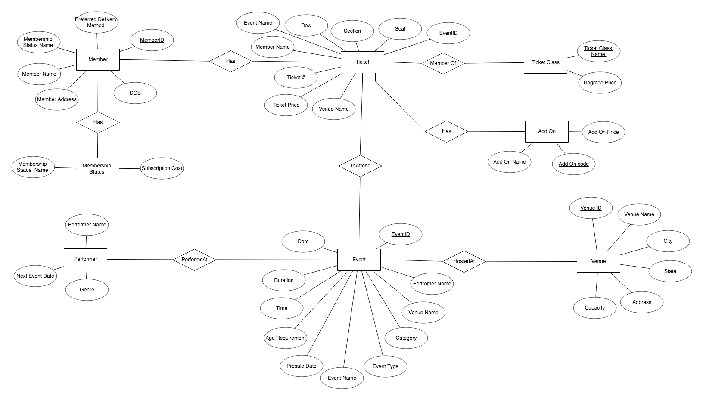

ERD Data Dictionary

|  |  |  |  |  |
| --- | --- | --- | --- | --- |
| Entity Type | Entity Type Description | Attributes | Key(s) | Relationships |
| Event | An event to which tickets are being sold on the website. | Date, Duration, Time, Age Requirement, Presale Date, Event Name, Event Type, Category, **Tickets Available**, Venue ID, Performer, Event ID | Event ID | An Event is Hosted At a Venue. |
| Venue | The venue at which the event takes place. | **Next Performer**, **Venue Type**, Venue Name, **City,** **State,** Address, Capacity, Venue ID, **Number of Wheelchair Accessible Seats**, **Next Event Date** | Venue ID | A Venue Hosts an Event. |
| Performer | An artist or musician who is selling tickets to an event on the website. | **Biography**, **Next Event Date**, Genre, Performer Name | Performer Name | A Performer Performs At an Event. |
| Member | A member of our service who can purchase event tickets. | Membership Status Name, Member Name, Address **(City, State, Address, Address2)**, DOB, Member ID, **City**, Preferred Delivery Method, Phone number | Member ID | A Member Has a Ticket. |
| Ticket | A ticket to that is associated to a seat at an event. | Event ID, Member ID, Venue ID, **Seat Location,** Section, Row, **Wheelchair Accessible**, Seat, Ticket Price, Venue Name, Ticket #, Add On Code | Ticket # | A Ticket is used To Attend an Event. |
| Add On | Perks that a customer could add to their ticket | **Code**, Add On Name, **Venue** **ID**, **Venue** **Name**, **Description**, Price | Code # | An add on is added to a ticket |
| Membership Status | A status associated with a member | Membership Status Name, **Ticket Discount**, Subscription Cost | Membership Status Name | A member can have a Status |
| Ticket Class | A group to which a ticket belongs, determines upgrade costs | Ticket Class Name, Upgrade Price | Ticket Class Name | Ticket is a member of a Ticket Class |

Schema

Event

|  |  |  |  |  |  |
| --- | --- | --- | --- | --- | --- |
| Event ID | Event Type | Event Name | Event Date | Time | **Duration** |
| Venue Name | Performer Name | Age Requirement | Category | Presale Date | Tickets Available |

Venue

|  |  |  |  |  |  |  |
| --- | --- | --- | --- | --- | --- | --- |
| Venue ID | Venue Name | Address | | **Next Performer** | | **Next Event Date** |
| **Number of Wheelchair Accessible Seats** | | | Capacity | **Venue Type** | Add on Code | |

Ticket

|  |  |  |  |  |  |  |
| --- | --- | --- | --- | --- | --- | --- |
| Event ID | Event Name | Venue Name | Ticket Number | Member Name | Section | Row |
| Seat | Ticket Price | Ticket Class Name | Ticket Class Price | Wheelchair Accessible | Add-on Code |

Member

|  |  |  |  |  |  |  |
| --- | --- | --- | --- | --- | --- | --- |
| Member ID | Member Name | Address | Phone Number | DOB | Preferred Delivery Method | Membership Status Name |

Performer

|  |  |  |  |
| --- | --- | --- | --- |
| Performer Name | Genre | **Next Event Date** | **Biography** |

Ticket Class

|  |  |  |  |
| --- | --- | --- | --- |
| Ticket Class Name | Venue Name | Price of Upgrade | Parking Included |

Add On

|  |  |  |  |  |  |
| --- | --- | --- | --- | --- | --- |
| Code | Name | **Venue ID** | **Venue Name** | **Description** | Price |

Membership Status

|  |  |  |
| --- | --- | --- |
| Status Name | **Ticket Discount** | Subscription Cost |

Schema Data Dictionary

|  |  |  |  |  |  |
| --- | --- | --- | --- | --- | --- |
| Table | Table Description | Primary Key | SuperKey | Attributes | Foreign Keys |
| Member | A member of our service who can purchase event tickets. | Member ID | Member ID | |  |  | | --- | --- | | MemberID | String | | MemberName | String | | Address | String | | PhoneNumber | String | | DOB | String | | PreferredDeliveryMethod | String | | MembershipStatusName | String | |  |
| Performer | An artist or musician who is selling tickets to an event on the website. | Performer Name | Performer Name | |  |  | | --- | --- | | PerformerName | String | | Genre | String | | NextEventDate | String | | **Biography** | **String** | |  |
| Ticket | A ticket to that is associated to a seat at an event. | Ticket ID | Ticket ID | |  |  | | --- | --- | | EventID | String | | EventName | String | | VenueName | String | | TicketNumber | Int | | MemberName | String | | Section | Int | | Row | Int | | Seat | Int | | Event ID |
| Event | An event to which tickets are being sold on the website. | Event ID | Event ID | |  |  | | --- | --- | | EventID | String | | EventType | String | | EventName | String | | EventDate | String | | Time | String | | **Duration** | **Int** | | VenueName | String | | PerformerName | String | | AgeRequirement | Int | | Category | String | | PresaleDate | String | | **TicketsAvailable** | **Int** | |  |
| Venue | The venue at which the event takes place. | Venue ID | Venue ID | |  |  | | --- | --- | | VenueID | String | | VenueName | String | | Address | String | | **NextPerformer** | **String** | | **NextEventDate** | **String** | | **WheelchairAccessibleSeats** | **Int** | | Capacity | Int | | **VenueType** | **String** | | AddOnCode | String | |  |
| Add On | An add-on that can be added to a ticket. | Add On Name | Add On Name | |  |  | | --- | --- | | AddOnCode | String | | AddOnName | String | | AddOnPrice | Double | |  |
| Membership Status | A status that a member can have. | Status Code | Status Code | |  |  | | --- | --- | | Status Name | String | | Subscription Cost | Double | |  |

Database Tool Work Area

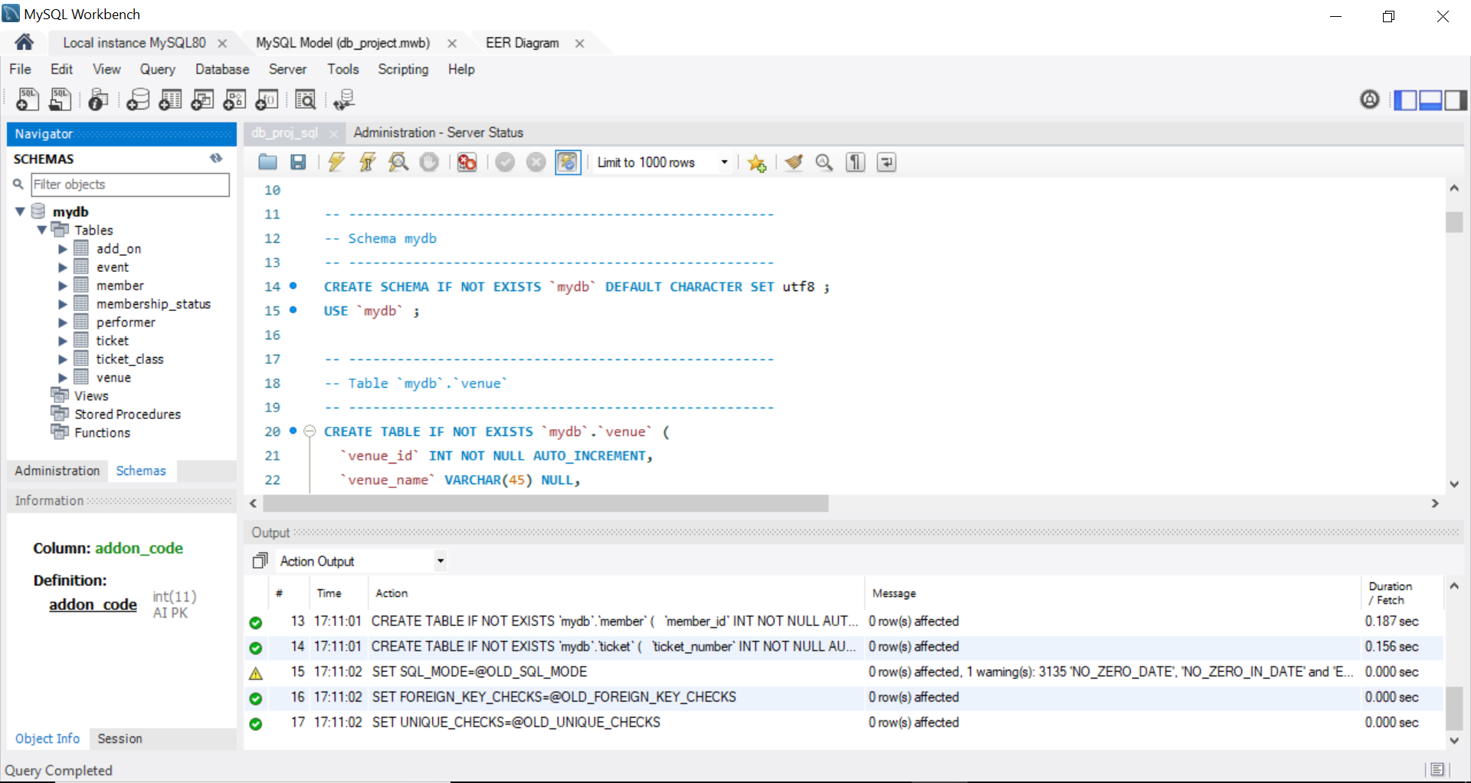

SQL Supported Statements

CREATE

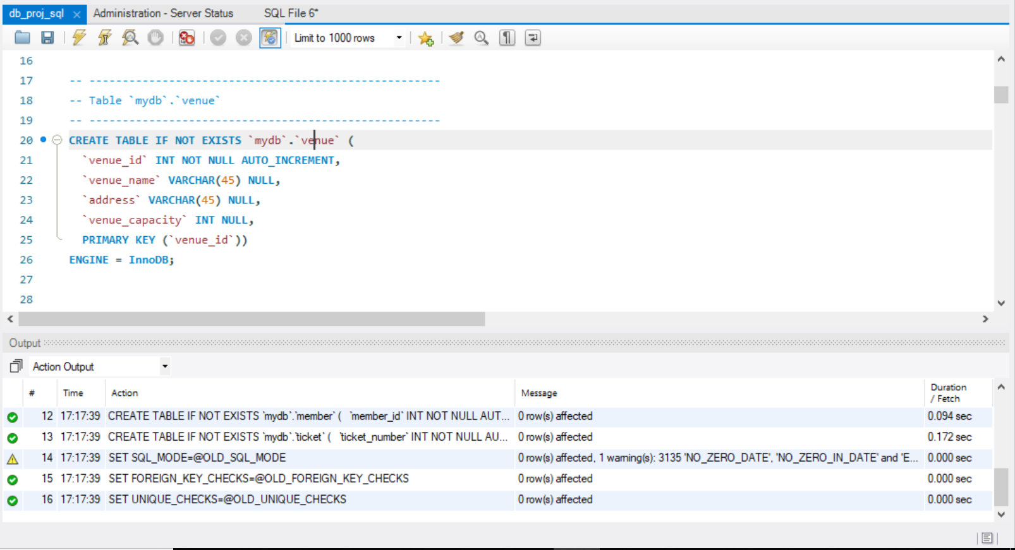

SELECT

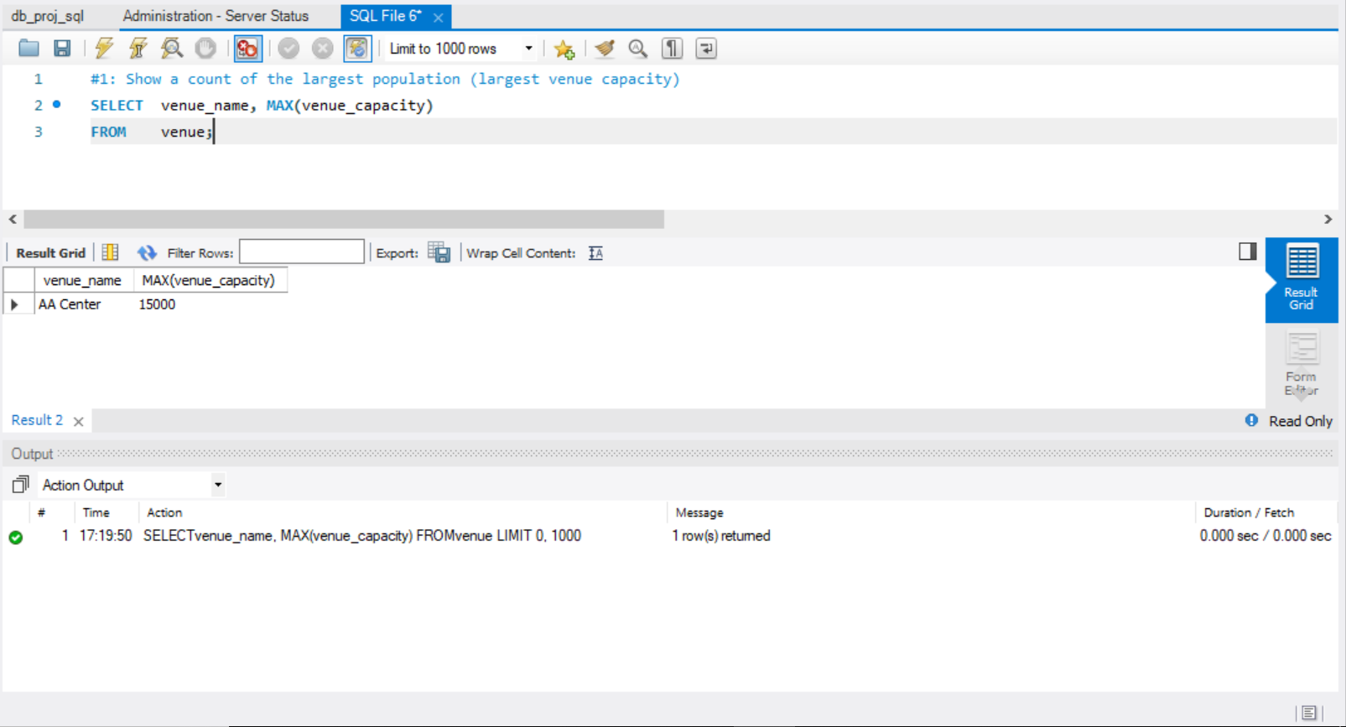

INSERT

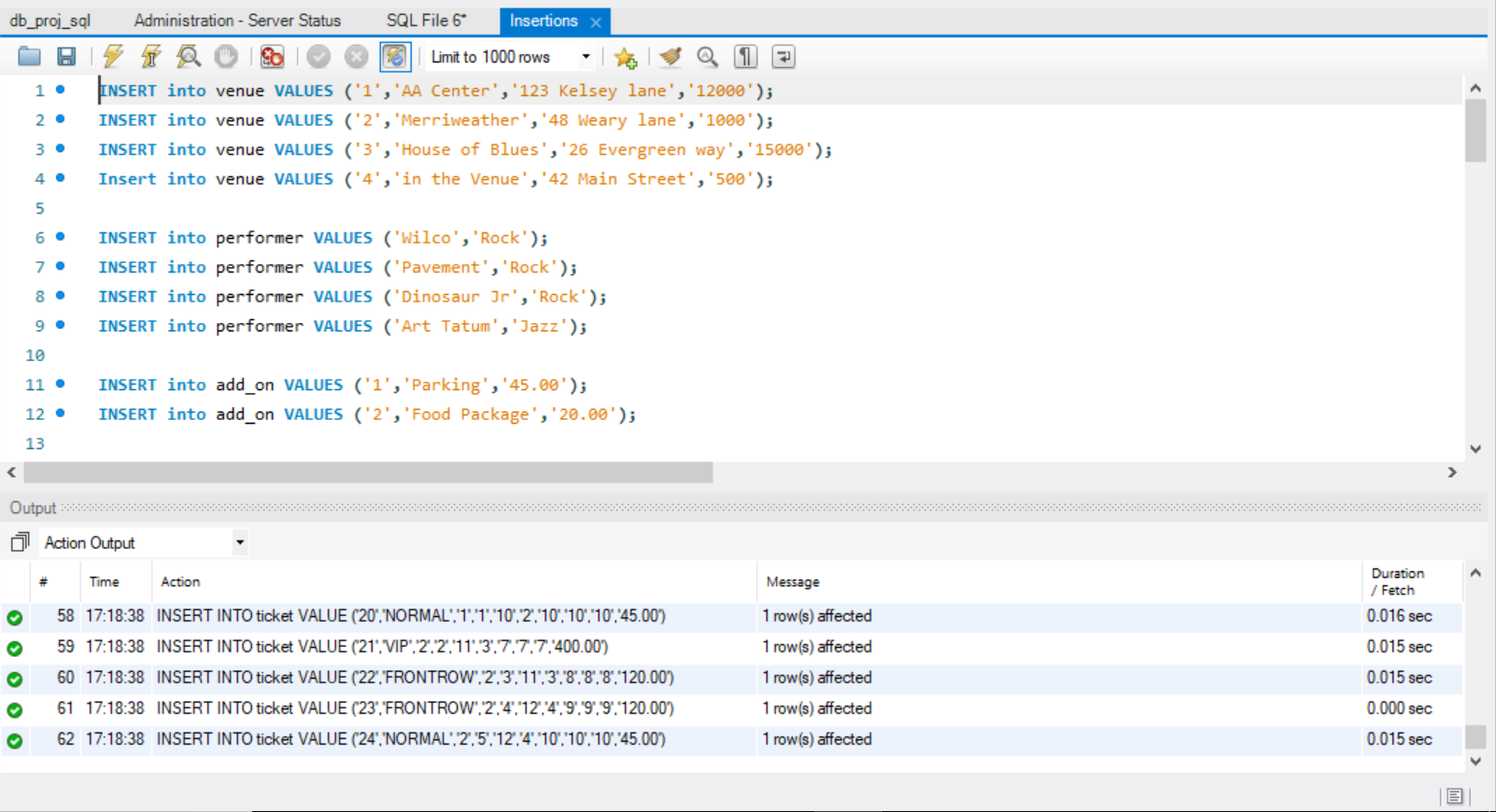

DELETE

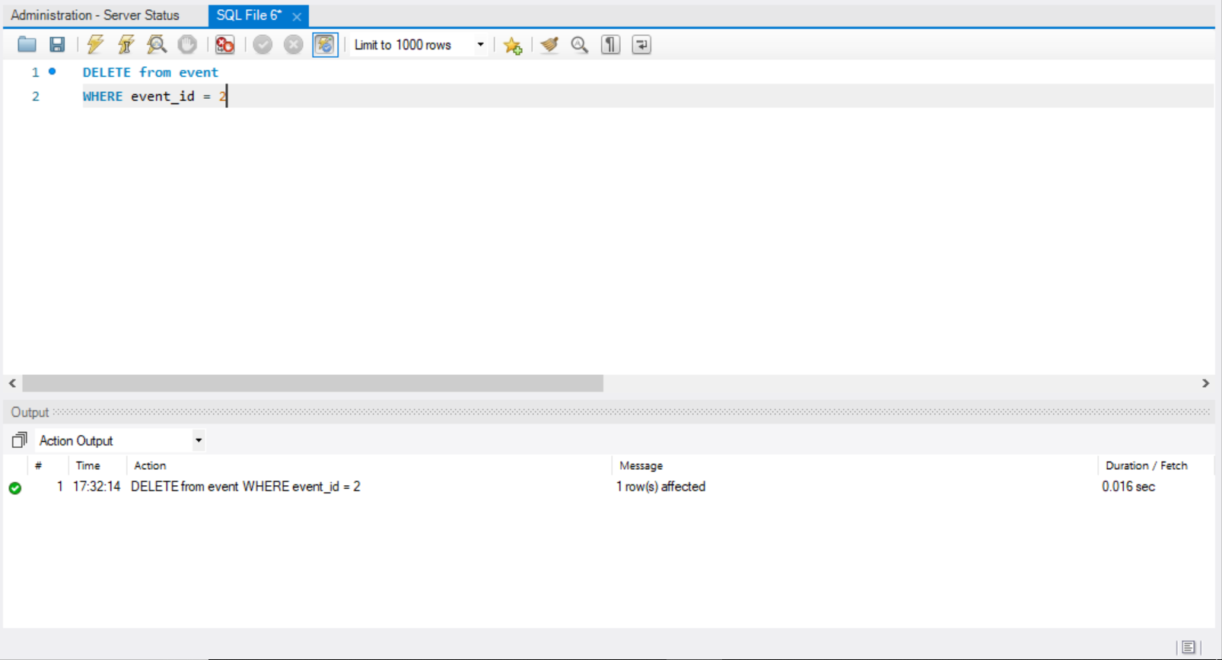



UPDATE

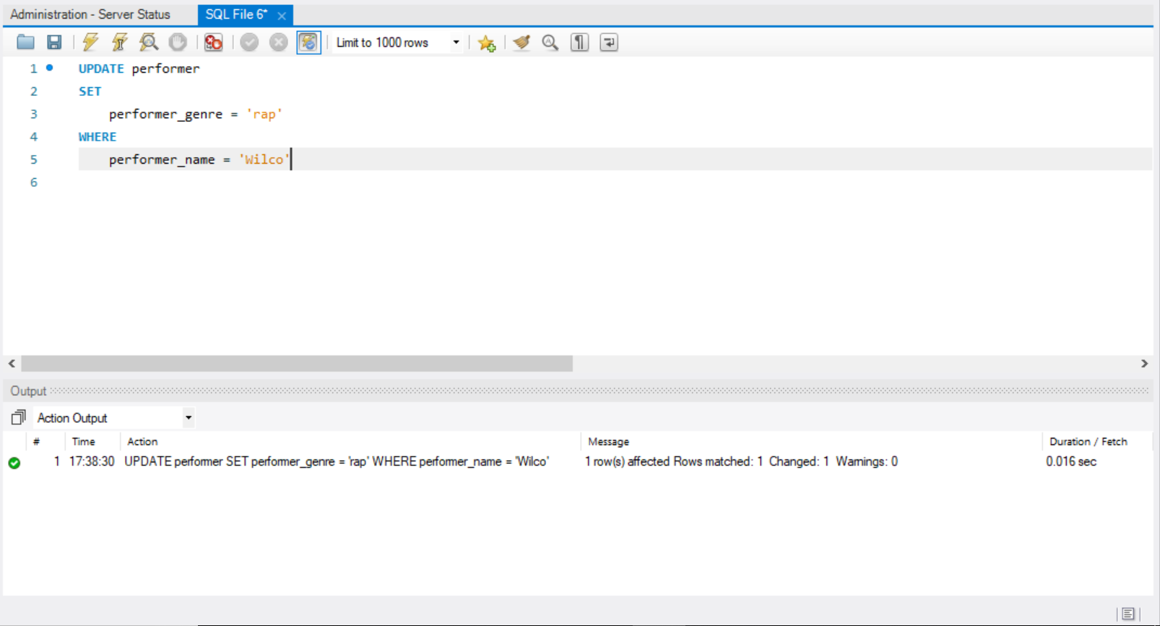

DROP

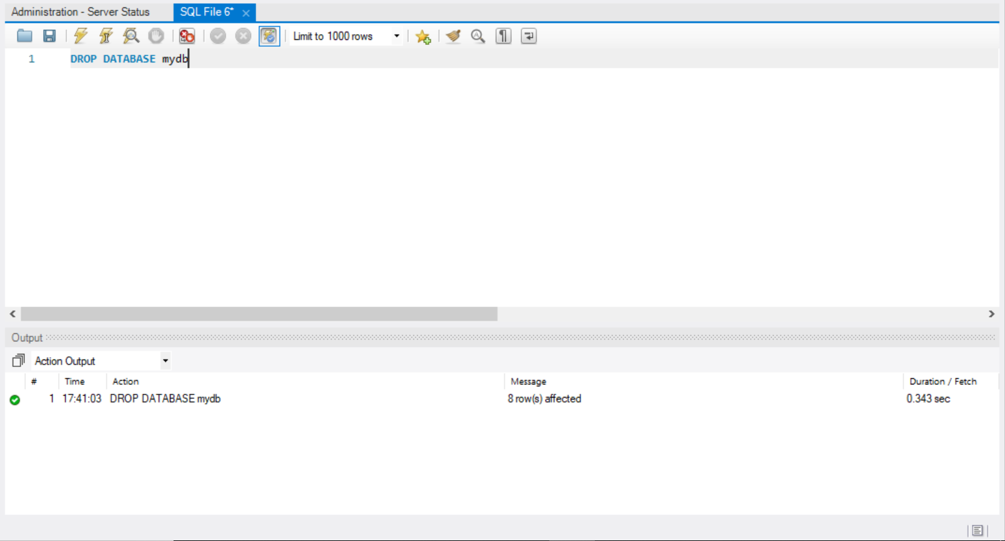

Implementation Log

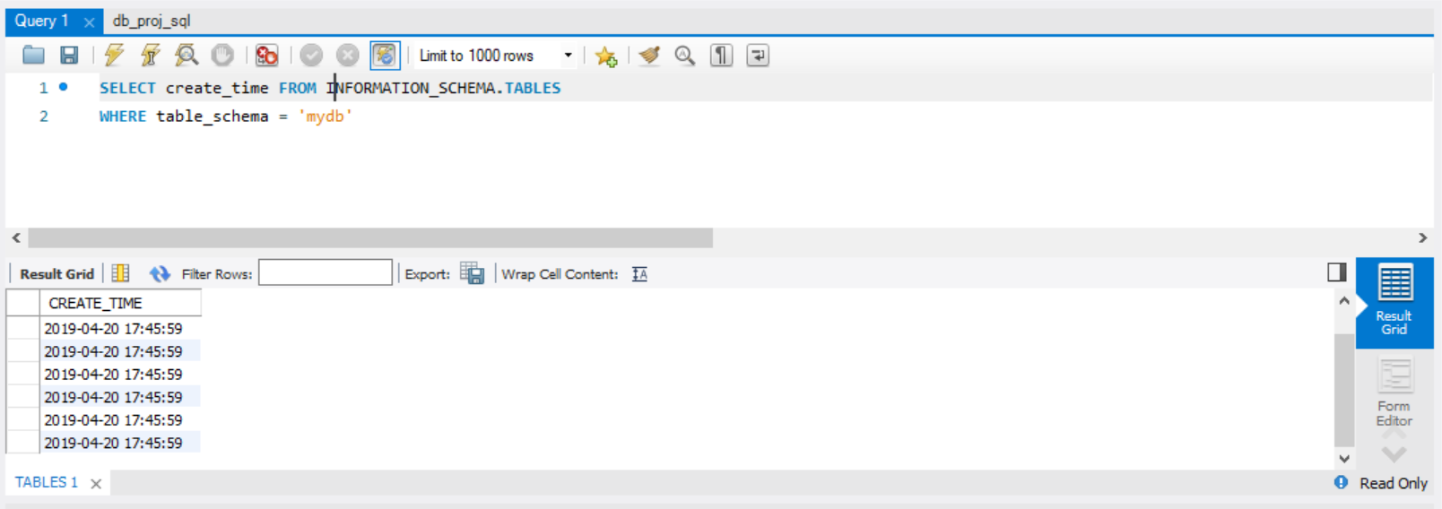

Data Generation

**Table Sizes**

Event – 30 Events

Venue – 30 Venues to select from

Ticket – 500,000 or more tickets throughout the year

Member – 10,000 members

Performer – 50 Artists

Ticket Class – At least 3 types (Handicap, Standard, VIP) but depends on venues

Add-on – Multiple, dependent on venue

**Table Data**

Event

|  |  |  |  |  |  |  |  |  |  |  |
| --- | --- | --- | --- | --- | --- | --- | --- | --- | --- | --- |
| Event ID | Event Name | Event Type | Event Date | Event Time | Event Duration | Venue ID | Performer Name | Age Requirement | Category | Presale Date |
| 22 | Summer Jam | Concert | 2019-6-02 | 8:45 PM | 60 | 1 | Pavement | 21 | Music | 2019-5-20 |

Venue

|  |  |  |  |
| --- | --- | --- | --- |
| Venue ID | Venue Name | Address | Venue Capacity |
| 1 | AA Center | 135 Kelsey Lane | 12000 |

Ticket

|  |  |  |  |  |  |  |  |  |  |
| --- | --- | --- | --- | --- | --- | --- | --- | --- | --- |
| Ticket Number | Ticket Class Name | Add-on Code | Member ID | Event ID | Venue ID | Section | Row | Seat | Ticket Price |
| 16535 | VIP | 1 | 1394 | 22 | 1 | 13 | 21 | 9 | 400.00 |

Member

|  |  |  |  |  |  |  |
| --- | --- | --- | --- | --- | --- | --- |
| Member ID | Member Name | Membership Status Name | Address | Phone Number | Member DOB | Member Preferred Delivery |
| 1394 | John | Bronze | 123 Main Street | 214-793-0001 | 1997-2-16 | Email |

Performer

|  |  |
| --- | --- |
| Performer Name | Performer Genre |
| Pavement | Rock |

Ticket Class

|  |  |
| --- | --- |
| Ticket Class Name | Upgrade Price |
| VIP | 45.00 |

Add-on

|  |  |  |
| --- | --- | --- |
| Add-on Code | Add-on Name | Add-on Price |
| 1 | Parking | 45.00 |

Queries

**#1**: Show a count of the largest population (largest venue capacity)

**SELECT** venue_name, **MAX**(venue_capacity)

**FROM** venue;

**#2**: Show a listing of a key entity in the database (events over a period of time)

**SELECT** event_id, event_name, venue_id, event_date

**FROM** event

**WHERE** event_date **BETWEEN** '2019-6-1' **AND** '2019-7-1';

**#3**: Show a list of entities that must function together () - returns tickets to a single event

**SELECT** ticket.ticket_number, event.event_name, venue.venue_name

**FROM** ticket, event, venue

**WHERE** event.event_id = 4 **AND** ticket.event_id = event.event_id **AND** venue.venue_id = event.venue_id;

**#4**: Show the cost of an occurrence, derived using aggregate functions (Total revenue)

**SELECT** jtable.event_id, SUM(jtable.ticket_price + jtable.upgrade_price)

**FROM** (

**SELECT** e.event_id, t1.ticket_number, t1.ticket_price, tc.upgrade_price

**FROM** ticket_class tc

**LEFT** **JOIN** ticket t1 **ON** t1.ticket_class_name = tc.ticket_class_name

**LEFT** **JOIN** event e **ON** e.event_id = t1.event_id

**WHERE** e.event_id = 1

) as jtable;

**#5**: Show a schedule for multiple occurrences, sorted by date and time (Schedule for a venue)

**SELECT** v1.venue_name, e.event_name, e.event_date

**FROM**  event e

**LEFT** **JOIN** venue v1 **ON** v1.venue_id = e.venue_id

**WHERE** e.event_date **BETWEEN** '2019-7-1' **AND** '2019-8-1'